E-Safety – Online Scams

1 of 18 – Introduction
Welcome to this session on online scams.
By the end of this session, you will be able to:
- Know what a scam is
- Understand the different types of online scams
- Understand in detail what phishing and other types of scam are
- Identify ways in which scammers try to defraud you
- Understand how to protect yourself against scammers

2 of 18 – What is a scam?
A scam can appear in many different forms, but they are all ultimately designed to part you from your money. You may get a message via email, text or any social media messaging service, all with the intention of tricking you into giving over your details or giving the scammers money. Almost half of all victims of these scams are those aged 18 to 34, so it is important to remember to stay vigilant.
Scams have always existed in different forms and have changed and adapted through the years. There are accounts of a ship owner who tried to sink his ship to claim the insurance money in 360 BCE. One of the most famous con artists of all time was Victor Lustig, the man known for “selling” the Eiffel Tower – twice.
In more modern times scams have evolved, mostly moving online. A stereotypical example of a modern scam would be the ‘Nigerian Prince’ scam, also known as a 419 or advance-fee scam. This scam works by emailing a target saying there is money held in a Nigerian bank, and you just need to pay a small fee to get access to it.

3 of 18 - Different types of online scams
There are many different types of online scams, some of which we will look at in detail later in the session. Read the list below to see the most common types of online scams.
- Phishing scams
- Fake antivirus software
- Social media scams
- Mobile phone scams
- Social engineering scams
- Software service fraud
- Romance scams
- Fake Wi-Fi hotspots

4 of 18 - Romance scams
One in five people meet their partner through online dating services such as Tinder, Bumble, or eHarmony. As they grow more popular, so does the potential for scammers to make money. Romance scammers are fraudsters who use fake profiles to manipulate a victim emotionally with the intention of stealing their money.
Usually, a bond will form with these scammers and things will quickly escalate from there. These fraudsters are often very affectionate, showering a victim with kind words and positive attention. This kind of attention can occur in normal relationships and is sometimes called ‘love bombing’. This is a technique used to try and trap people in a relationship by emotionally indebting a target to the perpetrator. The fraudster may also suggest moving off the dating platform quickly, as if their profile is found to be fraudulent by the site and banned or deleted, they can remain in contact with the victim.
This emotional hook is followed by an inciting incident where the fraudster asks for the victim’s financial help. They may have arranged to visit the victim but will use a range of excuses to try and trick the victim into sending them money. For example, they may claim to have an ill relative, or that they are stranded in a country they don’t want to be in, hoping that the victim will offer to help financially. Some fraudsters will also send money or valuable items to their victim, asking for them to be sent elsewhere. This is a way to hide criminal activity and launder money.

5 of 18 – Imposter websites
Imposter websites are sites which look and behave almost exactly like the real version of a website they are imitating. The URL to the website might be slightly different, or the layout may look a little ‘off’, but it is generally difficult to spot unless you’re careful. For example, a website could be created to look like barclaycard.co.uk with the URL barclaycard.co.uk in the hopes of getting victim’s login and payment details. These look the same, but in the latter URL the ‘L’ is replaced with a capital ‘i’.
Usually, people click on these sites as a panicked response to something like a threatening text or email. Scammers often pay for a fraudulent site to show higher up on Google search results in the effort to trick more people into visiting it.

6 of 18 – Fake websites
Fake websites differ from imposter websites, as they do not pretend to be an ‘official’ website, but instead tend to be filled with deals that are too good to be true. You might see a website selling something expensive and collectable, like Nike Air Jordans for half of their retail price.
These sites are often set up simply to get victims to enter their personal and banking details, with no intention of sending a product out. Alternatively, you may receive a poor, low-quality replica of the product and not the real thing.
Read more about spotting fraudulent websites here.

7 of 18 – Tech support scams
Tech support scams usually begin by having a pop-up appear on the screen telling the user they have some sort of problem with their device such as ‘viruses’ or ‘hackers’. The type of pop-up used appears like they can't be closed and usually contain a number to call, or a link to click on to get ‘help’ with the problem. The pop-up may look serious, often imitating the branding used by large companies like Apple, Microsoft, McAfee or Norton.
Another variation of this may be a company claiming that you are entitled to a refund for a purchase you made on some sort of software. If a victim has already paid for the ‘fix’ as mentioned earlier, another fraudulent company will purchase the victim’s details from the first company, then use that information to try and scam the same victim in this way by claiming they overpaid for the fix, and once they gain access to the victim’s device will steal more money from them.
Ultimately these scammers try to gain remote access to your computer, giving them the ability to manipulate the information you can see, as well as misrepresent regular computer information as a way of explaining these fictitious viruses. For example, they may show you the Event Viewer (as shown on the image) to raise concern. However, these errors are normal and nothing to worry about.
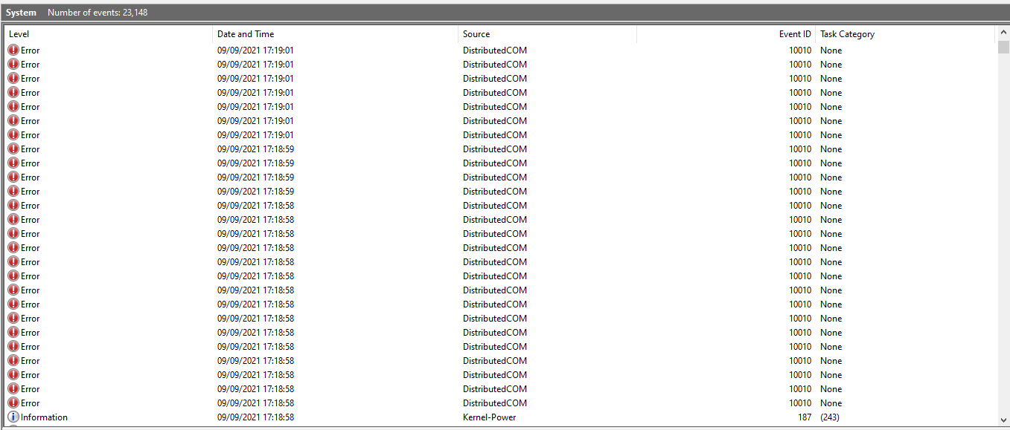
For more information on how these scams work, watch this video by clicking on the link.

8 of 18 – Phishing scams
Phishing scams can come in many forms, but all essentially try to do the same thing; trick a target into revealing personal information which can be used by the fraudsters for financial gain. Phishing scams evolve over time, starting with the simple ‘Nigerian Prince’ scam as mentioned earlier, to modern attempts which involve sending emails, text messages or calling people and impersonating a legitimate business such as a bank, PayPal or Amazon.
For example, you may get a text or email from someone claiming to be your bank telling you there is a block or some other issue with your account. It will probably provide a shortened link or a link to a website which looks legitimate. Then, when you attempt to put in your details to log in to your account, the phishers will store your banking details.
It is important to look at who the sender is when you receive messages like these, as scammers will not be able to use the company’s real name. For example, no-reply@bank.com might be an email from your real bank, whereas no-reply@bank-alert.com could be from a scammer. Never click a link you receive in an email or text message. Remain calm, even if the message appears serious and legitimate, and simply visit the real website of whoever is trying to contact you or call them and explain the situation. If there is a real issue the business will help you fix it. If not, you can block and report the scammers’ number.

9 of 18 - Phishing on social media
There are other types of phishing scams which take place on social media. Read through the list below to learn more.
Social engineering scams.
Social engineers are those who try to exploit human behaviour to conduct a cyberattack. This is similar to the tech-support scam mentioned earlier in the session but is usually more personal. It may involve someone targeting a specific victim, as opposed to sending out thousands of emails. This person might try to integrate themselves into your life by becoming a friend, and over time as you reveal personal information (such as date of birth etc). Once they have enough information, they will try to access your online accounts in an effort to extort or steal from you.
Too good to be true scams.
Probably the most common way of tricking people into revealing information about themselves online is by using a social media scam. You may receive messages with phishing links in, or see real friends who have been hacked sharing links to heavily discounted items, free apps, films etc. These phishing links will take you to a fake website which takes as much information from you as possible and may even try to get you to input additional information to access the false “service”.
Online quizzes.
Online quizzes shared on social media can be ways to get your personal information. For example, a “What Disney Character Are You?” quiz might ask for the month you were born, and what your first pet was, as well as other seemingly innocuous questions. Or you might fill out a “What is your wrestler name?” quiz, that uses a street name that you grew up on, or the place you were born to provide an answer. These might seem like fun, but on most websites the information you share on these quizzes will act as a way to reset your account. This means by giving out this information, the site can then use it to close you out of your account, blackmail you back into it, or gain access to other more important accounts.

10 of 18 - Identifying online scams
Despite the varying types of online scams, there are many ways of spotting these scams before you fall victim to them. Read through the list below to learn about some of the things to watch out for.
- Unexpected contact – Getting cold calls or messages out of the blue
- Confirm these details – People asking you to confirm or share personal details
- Inaccurate contact details – Similar-sounding domains to legitimate businesses but they don’t match the official site
- Pressure – Being pressured into dealing with whatever they say immediately; no legitimate business operates in this manner
- Too good to be true – What really are the chances you won a cruise if you never entered a competition to do so?
- Keep it quiet – Being pressured into keeping the discussion secret, or dissuading you from sharing concerns with family or friends

11 of 18 - Protecting yourself from online scams
Protecting yourself against online fraudsters is difficult as methods and techniques of protection evolve over time. Look through the list below to view some general tips to keep you and your personal details safe online.
Don’t open links in any type of message
- If the message seems serious, go directly to the official website of the business and get in touch with them through that.
Don’t use the same password for every website
- This can be difficult, but for important online accounts make sure to use unique passwords that aren’t easily guessable. For example, don’t use your surname then date of birth. It’s much better to pick 3 random words, and 3 random numbers, and combine those into a unique password. HorseFarmingHippo120 is much more secure than Smith07, and quite easy to remember.
Check if your personal details have been shared online
- Visit the website linked below to see if your details have been shared online. This can be anything from your email address, to passwords and phone numbers. If they have, you can see which sites they came from by clicking the subscribe button – then update your passwords.
https://haveibeenpwned.com/
Use a password manager
- A password manager is an app or website where you store your passwords and information. You then secure the app by using 1 very strong password. This might seem like it is easier for someone to gain access to all of your information, but in actuality using one strong password never used on any of your online accounts before will better protect your other passwords. This way, all of your other passwords can be unique, and you don’t have to worry about remembering all of the details, which remain safe and easy for you to access.
Use two-factor authorisation
- Two-factor authorisation (2FA) lets you add an additional step when you log into your account. This is helpful as it usually involves sending a text or email to a device the site knows you have logged into before and making you authenticate the new login from there.

12 of 18 - Reporting an online scam
Being scammed can feel embarrassing or shameful, and as a result it is estimated only around 16% of online scams are reported. More people reporting these events can make an impact on how government develops defences against these online criminals. If someone scams you or a family member, it is important to report the fraud to an organisation who can help.
Citizens Advice can give you advice online or over the phone about what to do if you are scammed online. You can report an online scam directly to them, and they pass this information to trading standards. They have a helpful page with suggestions of what to do if you’ve been scammed which can be found by clicking this link.
You can also report the scams to the Action Fraud cybercrime service. Action Fraud is the National Fraud & Cyber Crime Reporting Centre, in charge of processing and reporting fraudulent activity in the UK. You can report crime to them on their website, or by calling them. The information you give to Action Fraud is passed on to other police forces, regulatory bodies and authorities to cross reference and build a case against these online criminals.

13 of 18 – Question 1
What age group are most likely to fall victim to a scam?
- 18 to 34
- 35 to 55
- 56 to 75
- 75+
The correct answer is A, 18 to 34-year olds.

14 of 18 – Question 2
What is a romance scam?
- Using pictures of someone you are dating and creating a fake online profile
- Using an online dating service to manipulate someone into giving the scammer money
- Blackmailing someone who you have explicit pictures of into giving you money
- Using online dating services to cheat on your partner
The correct answer is B.
A romance scam is when someone uses an online dating service to manipulate people into giving them money.

15 of 18 – Question 3
Use the following words to complete the sentence below by filling in the blanks.
Phishing
Trick
Personal
Financial
A BLANK scam is when a scammer tries to BLANK a target into revealing BLANK information which can be used by the fraudsters for BLANK gain.
The correct answers are:
A phishing scam is when a scammer tries to trick a target into revealing personal information which can be used by the fraudsters for financial gain.

16 of 18 – Question 4
Which of the following could be signs of someone trying to scam you? Select all that apply.
- Unexpected contact
- A relative needing aid
- Being pressured into compliance
- Being asked to confirm personal details
- Your bank calling you about a fraudulent transaction
- Being asked to keep the conversation a secret
The correct answers are A, C, D and F.
Unexpected contact – Getting cold calls or messages out of the blue
Pressure – Being pressured into dealing with whatever they say immediately. No legitimate business operates in this manner
Confirm these details – People asking you to confirm or share personal details
Keep it quiet – Being pressured into keeping the discussion secret, or dissuading you from sharing concerns with family or friends

17 of 18 – Question 5
Use the following words to complete the sentence below by filling in the blanks.
Two-factor
Password
Protection
You should use BLANK authentication, combined with a BLANK manager to remember unique passwords for your online accounts for the best BLANK possible.
The correct answers are:
You should use two-factor authentication, combined with a password manager to remember unique passwords for your online accounts for the best protection possible.

18 of 18 – Conclusion
Well done! You’ve completed this session on online scams.
You should now be able to:
- Explain what a scam is
- Understand the different types of online scams
- Understand in detail what phishing and other types of scam are
- Identify ways in which scammers try to defraud you
- Understand how to protect yourself against scammers

